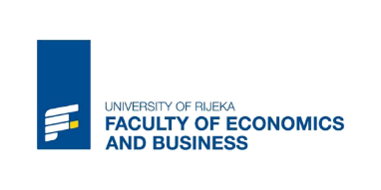
Statement on Personal Data Protection
I, ________________________ hereby authorize the Faculty of Economics and Business of the University of Rijeka to process my personal data (given in the application form) for the purposes of organization of the Summer School 2022 Programme.
This permission applies to, and should not be intended to any other usage
(please mark the field with "x" for which you are giving the permission):
selection process, accommodation arrangements, transport arrangements, attendees' registration for visits to official institutions and companies, booking for social events, accreditations, certification related to the programme
inclusion in the official Brochure of the Summer School 2022 with photos of the participants, e-mails, telephone numbers, and parts of motivation letters
usage of selected photo and video contents for current and future Summer school promotional materials.
According to the legal regulations, if necessary, the data will be delivered to the third parties for the organization of the activities related to the Summer School 2022 Programme.
The Faculty commits itself to collecting personal data based on this explicit consent with the application of all prescribed legal, organizational and technical data protection framework prescribed by the General Data Protection Regulation (EU Regulation 2016/679).
All guaranteed rights in accordance with the EU Regulation regarding your personal data you can obtain by written request to the email address summerschool.team@gmail.com.

Date Signature

_____________________ ________________________

